Ecological conditions of Amurskiy and Ussuriiskiy Bays of the Sea of Japan and of the rivers flowing into them

Anatoliy L. Drozdov^{1,2}, Galina V. Moyseychenko³, Konstantin A. Drozdov⁴ and Tatyana S. Vshivkova⁵

¹A.V. Zhirmunsky Institute of Marine Biology FEB RAS, Vladivostok 690059, Russia.
E-mail: anatoliyld@mail.ru
²Fareastern Federal University, Vladivostok 690091, Russia;
³Pacific Scientific Research Fisheries Center, Vladivostok 690091, Russia.
⁴G.B. Elyakov Pacific Institute of bioorganic Chemistry FEB RAS, Vladivostok 690022, Russia.
⁵Institute of Biology and Soil Science FEB RAS, Vladivostok 690022, Russia.

Polluted rivers and waste water flowing into the littoral zone are the main sources of pollutants entering the sea. Estuaries and marine bays with rivers flowing into them are subjected to great anthropogenic influence. Concurrently these areas are defined by significant variation of primary abiotic factors, largely of temperature and salinity. Such situations require careful study of the biota’s response to pollution, depending on the fluctuation of natural physicochemical parameters of the environment. In this case, it is possible to find reliable information on possible physiological alterations in organisms as the result of combined effects of natural and anthropogenic factors.
The composition of bottom sediments in water bodies is highly influenced by anthropogenic factors. Large quantities of contaminants (heavy metals, surfactants and supertoxins) have accumulated on the bottom. Concentrations of chemical substances in bottom sediments exceed their concentration in the water column by several orders of magnitude.
Some chemical compounds can modify their properties as a result of chemical and metabolic transformation (e.g., the methylation of mercury) and become more dangerous for hydrobionts. On the contrary, other compounds lose their biological activity through microbiological metabolism (e.g., some petroleum hydrocarbons).
We estimated the ecological condition of rivers entering Amurskiy and Ussuriiskiy Bays of the Sea of Japan using macroinvertebrates as biological indicators. Bioassessment of the marine waters was based on sea urchin embryo biotest (Kobayashi, 1974, 1981, 1990) of both sea water and bottom sediments from different areas of Peter Great Bay of the Sea of Japan.
Our bioassessment analyses provided reliable estimates of water quality, in both freshwater (Fig. 1) and marine (Fig. 2) environments. Analyses using bioindicators were able to distinguish between clean and polluted conditions and could detect zones of transformation of contaminants. The most polluted areas were Murav’inaya Bay and Shkotovka and Sukhodol estuaries of Ussuriiskiy Bay and the estuary of Razdo’naya River of Amurskiy Bay. This indictes that there is significant domestic and industrial pollution flowing into Amurskiy and Ussuriiskiy Bays from terrestrial sources (Fig. 3,4). The cleanest water was in Narva River, its estuary, and adjacent Amurskiy Bay, where the Narva discharges (Fig. 3).
We conclude that bottom sediments are more toxic than those in the water column. In estuaries where river flow is mixed with salt water, chemical transformation of pollutants occurs. Toxicity is particularly high in these areas.
Using bioassessment and biotesting we were able to obtain an overview of the spread of pollutants in the water cycle of Ussuriiskiy and Amurskiy Bays and the open marine zone of Peter Great Bay.

Fig. 1. Points on rivers where macroinvertebrates were gathered.

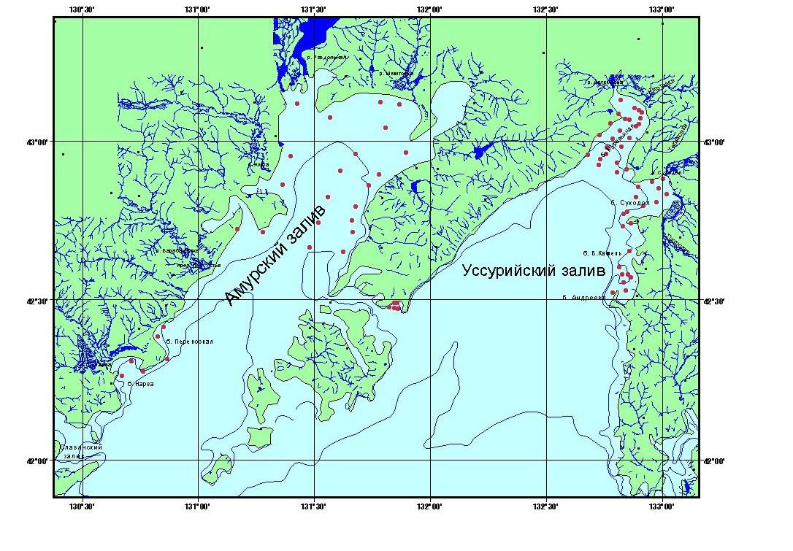
Fig. 2. Points on marine area where sea water and bottom sediments were tested.

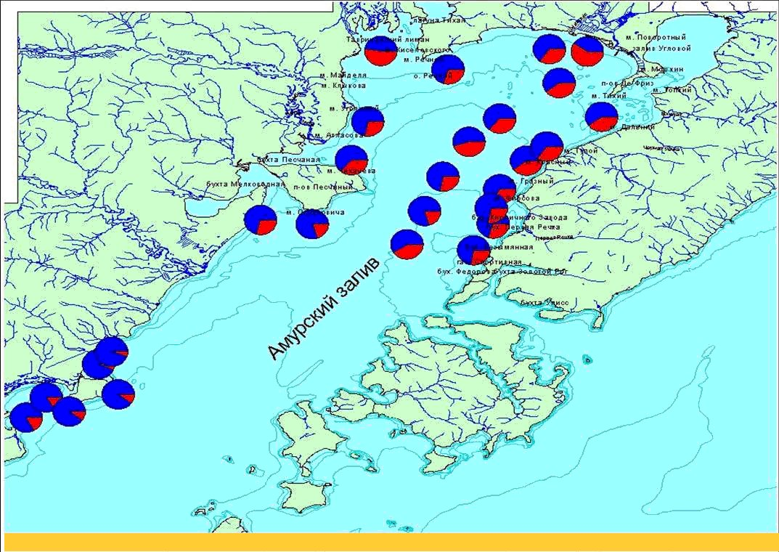

Fig. 3. Result of bioassessment analyses of bottom sediments in the Amurskiy bay. Blue – normal larvae on pluteus stages, red – misshapen larvae. The estuary of Razdolnaya river is most polluted, and estuary of Narva river is most clean.

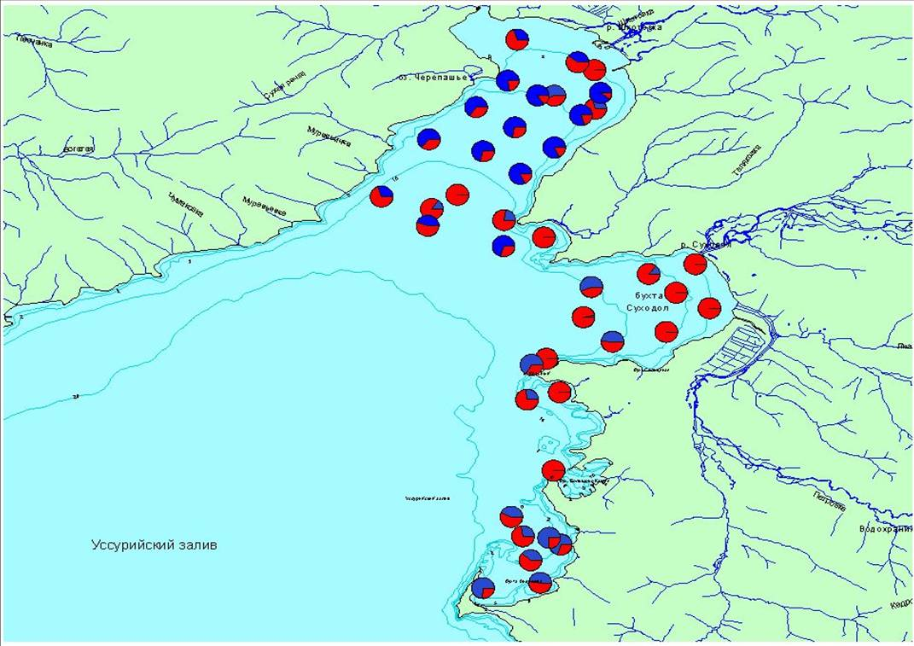

Fig. 4. Result of bioassessment analyses of bottom sediments in the Ussuriiskiy bay. Blue – normal larvae on pluteus stages, red – misshapen larvae. The estuary of Sukhodol river is most polluted.

References

Kobayashi N. 1974. Marine pollution bioassay by sea urchin eggs, an attempt to enhance accuracy // Publ. Seto. Mar. Biol. Lab. V. 21, N 5–6. P. 377–391.
Kobayashi N. 1981. Comparative toxicity of various chemicals, oil extracts and oil dispersant extracts to Canadian and Japanese sea urchin eggs // Publ. Seto. Mar. Biol. Lab. V. 26, N 1–3. P. 123–133.
Kobayashi N. 1990. Marine pollution bioassay by sea urchin eggs, an attempt to enhance sensitivity // Publ. Seto. Mar. Biol. Lab. V. 34, N 4–6. P. 225–237.

